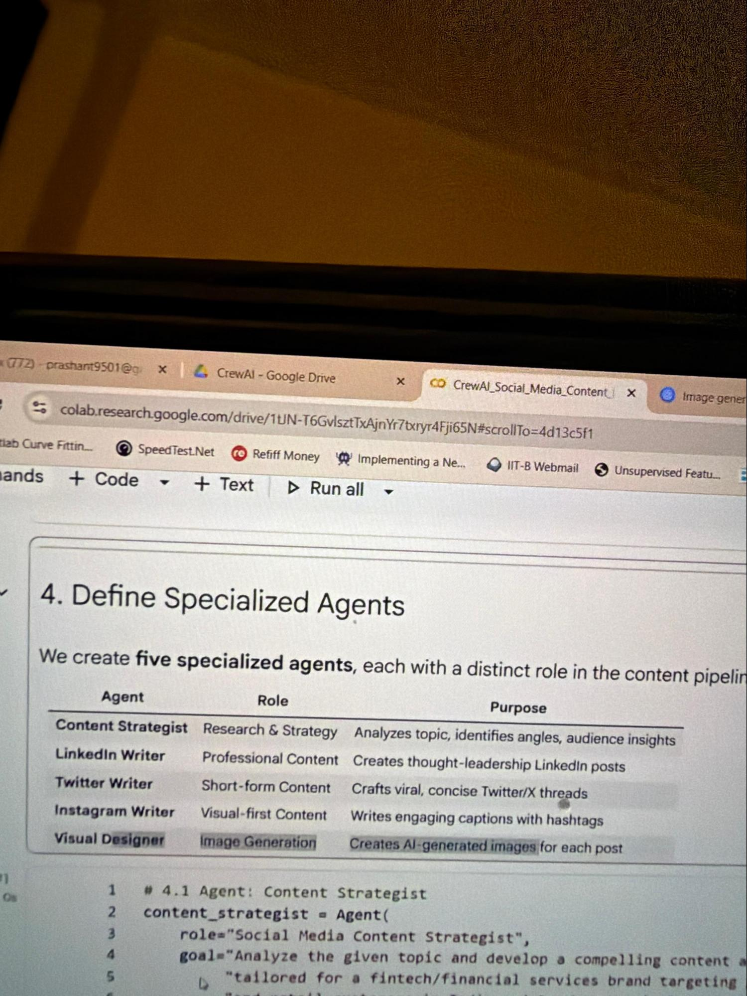

Great ideas
1. Create a markdown file with course structure and use it to ask future questions related to real world problem statements

1. Ask for design patterns (from existing labs)

Key is to have:

1. Project deliverables
2. Project scope
3. You are not starting from scratch - so labs and transcript will be referenced as catalogue
4. You repurpose the notebooks— upload all end to end notebooks and ask it summarise to create those design patterns

For students

1. Upload mark down files and then ask claude to create milestones and validate your goals by asking claude to review it

To tell the students
1. Code generated by claude will be outdated as model roughly gets trained 6 months ago so 90% code will not work as plugins and libraries are outdated
2, you can generate random code but review of each working use case takes atleast 20 hours from a very knowledgeable ai developer and architect and multiple rounds of feedback and revision cycles
3. Key is sc

Day 12 - Agentic A
While runnig the code test im the reflectkoor

Try

Scope ={}

Exec ( imprt_str , code _str, scope)

Scope is a sandbox in which the entire code execution would run rather that in the notebook

...

2:37:10

Using asyncio for multiple threads

Define a function

Async def function name()

{

}

Functio used parallely by different nodes

....

Check what is the rate limit and token amountsoʻ

Rate limit -- tpm token per min

Day 14

Create a agentic setup to generate social media content

Structure of agent (crew ai)

1. Role of agent
2. Task
3. Backstory
4. Tool

Refer to image attached which talks about the different agents being defined

There is no agent state like in langraph, the output of one agent is input for the other agent

. Crew Ai has atomic agents as in agents have really granular task, its hierarchical
and linear

. Langraph is workflow based, crew ai is role based-who is agent and what they do

. Process.sequential will run agents in a soecific sequence

. Manager agent can be a bigger model like opus and worker agents can be smaller models like gpt mini etc

Structure of crew ai notebook

• You define the agents - their roles
• You define their tasks
• then section 6 is assembling and running the crew agent

Structure of assembly:

SocialMedia_crew = crew (

Agents =[agent 1 name, agent 2 name, agent 3 name, ....]

Tasks =[ agent 1 task, agent 2 task , agent 3 task ..]

Process = process.sequential -- task run one after another

CrewAI Hierarchical Assembly TL;DR:
​Instead of running tasks in a rigid, step-by-step order, you set process=Process.hierarchical and assign a Manager LLM.
​The manager acts as the boss—autonomously delegating tasks to worker agents based on their skills, reviewing their work, and handling quality control.

• instead of invoke for langraph, crew ai has kickoff

Mcp server can have the capability to connect with live database and that is advanced usage of it

• Glob python library - can load specific file types/files across multiple files in a huge data set
• Can read a mark down file in specific directory

import glob

# Grabs every single JPEG image across all subfolders for training
training_images = glob.glob("dataset/train/**/*.jpg", recursive=True)

....

Question ?

1. How is the image being created

Lead generation and qualification ai

2. Towards the end he talks how the deployment will actually run via lambda function/ azure function and how would it run as an automated function

….

Day 15

Obseravibility and traceability

• • Observability-- high level view of the application , what , what are overall metrics, overall cost, latencyare overall metrics, overall cost, latency

• • Traceability-- low level and drill dowown view of the application

- Disect the model - what went into it, what came out of it

- Hn much time it took, how much was costing

•

....

Observability

1. Debugging
2. Cost management by identifying where is it being used.
3. Quality assurance in terms of identifying what data is used

Prompt caching nuances (for cost reduction)

1. To be able to save cost using prompt caching - for eg you may think that you can cache the system prompts which is common but the scenerio is that usually its around 5-10 lines, around 300-400 tokevs ,ihoweeer the minimum tok ns ohich can be cached is 1024 forf pen ai/gemini for claude is 4096 ,

So unless you have huge amounts of context to be cached they dontheven accapt caching

Promptp-

Static part -
1. Role
2. Goal
3. Constraints

Dynamic
1. Agent state
2. Actual user query

So if the static part is small , you cant really benefat from prompt caching

Refer prompt tiching guidelnnes-- ope

ai

To reduce costs by any ideas make sure you know the Constrain

- Disect the model - what went into it, what came out of it

- How much time it took, how much was costing

•
ts of the solution

....

Observability

1. Debugging
2. Cost management by identifying where is it being used.
3. Quality assurance in terms of identifying what data is used
4. for each interaction user can give feedback and can be captured

Prompt caching nuances (for cost reduction)

1. To be able to save cost using prompt caching - for eg you may think that you can cache the system prompts which is common but the scenerio is that usually its around 5-10 lines, around 300-400 tokens , however the minimum tokens which can be cached is 1024 for open ai/gemini for claude is 4096 ,

So unless you have huge amounts of context to be cached they dont even accept caching

Prompt -

Static part -
1. Role
2. Goal
3. Constraints

Dynamic
1. Agent state
2. Actual user query

So if the static part is small , you cant really benefit from prompt caching

Refer prompt caching guidelines-- open ai

To reduce costs by any ideas make sure you know the Constraints of the solution

• Llm evaluation : parameters are fixed based on tasks (classification tasks, question answering tasks, sentiment analysis task) and metricd are different

Setup for observability using sagemaker (need to investigate from transcript ?)

• you can retrieve details from one trace ( find out more what it means ?) - find latency/cost
•

Observability for below three points at these levels -

• application level
• agent level (state change)
• bussiness level (what are users asking /custoker satisfaction/cost per interaction)

Traceability

• basic level
• intermediate
• Full trace

Use case

• compliance scenerios
• prompt management

Tools used for Traceability

• langsmith, langfuse -
• phoneix (by arize Ai) - open source

Demo

1. Get api keys
2. Put langsmith key in notebook
3. Once Api key is present, it can do the tracing simply

Questions

Need to investigate what is a open ai sdk and claude sdk ?

..

Each langchain run will have

1. the id which can be retrieved
2. Latency
3. Input
4. Top 3 docs which were retrieved
5. If Vector store retriver is checked it would come separately

. A vector store retriever is like a high-powered search engine for AI. Instead of looking for exact keywords, it searches based on the meaning of your question to pull relevant information from a database

6. When u run the entire langraph - the agent it would appear as well —-> appear as a compiled langraph.
7. Standalone api call can also come
8. You can click and compare runs - side by side to check difference in performance
9. Trace and run , trace is for the entire agent snd run is one step inside execution
10. The retrieval should not exceed more than half a second , it shouldnt be more than that. 1 sec or more is expected if u r searching on millions of documents, also retrieval time should be in the range which is mostly stable if the vector database and retrieval strategy is fixed
11. Managed vector database solutions like pine cone —> you can give the directly give the chunks and they will do embeddings and retrieval is all happening on cloud but u can also bring your own computings and u can connect awe azure, zero access operating model — entire data resides in ur own vpc , pine cone will just add an application layer on top of it , there is database name and database collection
12. Claude doesnt have its own embedding which is voyage ai

…

